# Lab 1 - Creating a Repository

*Note: For the sake of these tutorials, we are assuming you are using a terminal capable of running Bash commands. For Windows users, the recommended terminal program for this is Git Bash, which you can download from <https://gitforwindows.org/>*

There are a few ways to create a repository. The first is from the command line.

|  |  |
| --- | --- |
| **Command** | **Function** |
| git **init** | Initialise a directory as a Git repository |

You can then create a remote directory in GitHub with the following steps:

1. Create a new directory on your local machine and initialise it as a Git repo with the following commands:

$ mkdir my-new-repository

$ cd my-new-repository

$ git init

1. Create a new README.md file with the following command:

$ touch README.md

1. Stage and commit the new file to the repository:

$ git add README.md

$ git commit -m "Initial commit"

This will complain that git doesn't know who you are. So, tell git using the following command:

$ git config user.email "<your github email address>"

Then run the commit command again:

$ git commit -m "Initial commit"

1. Navigate to GitHub on your browser and log in.
2. Click on the green **New** button to create a new repository.

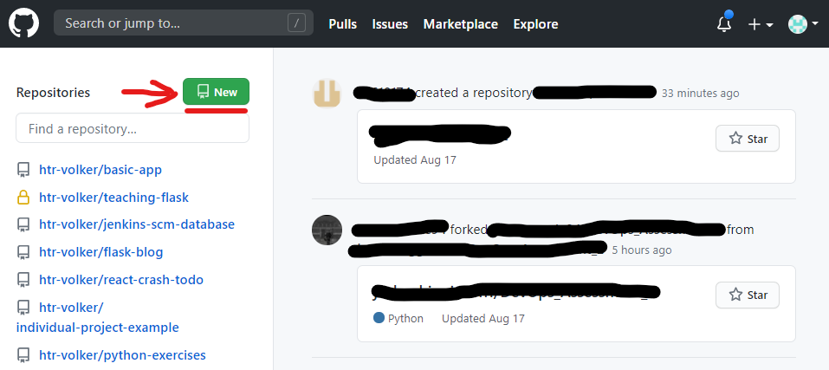

1. Enter the name of your new repository and press the **Create repository** button (keep the **Initialize this repository with a README** box unchecked).

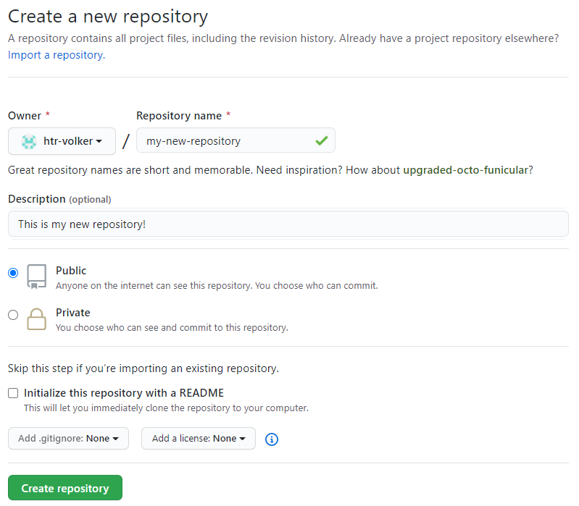

1. You should see a page like this, with some options for working with your repository. Copy the URL (with or without the .git extension, it doesn't matter) for the repo as specified at the top of the page:

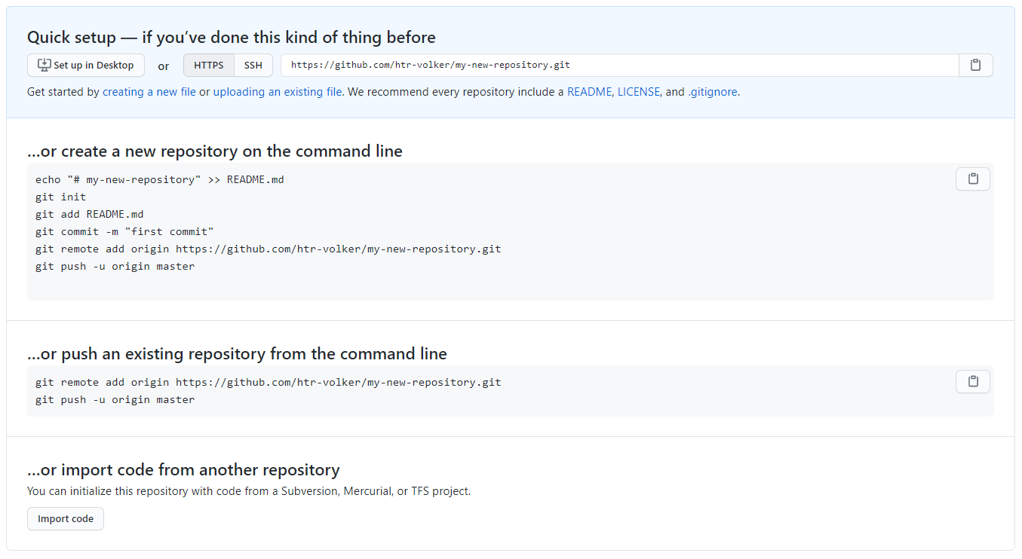

1. Finally, fun the following commands in your Bash terminal, replacing the URL for that of your new repository:

$ git remote add origin https://github.com/[YOUR_USERNAME]/[YOUR_REPOSITORY]

$ git push -u origin master

You might be asked for your GitHub credentials at this point, so that your PC can authenticate against the remote GitHub website. So, if necessary, enter your GitHub username and password. Your terminal output should look similar to this:

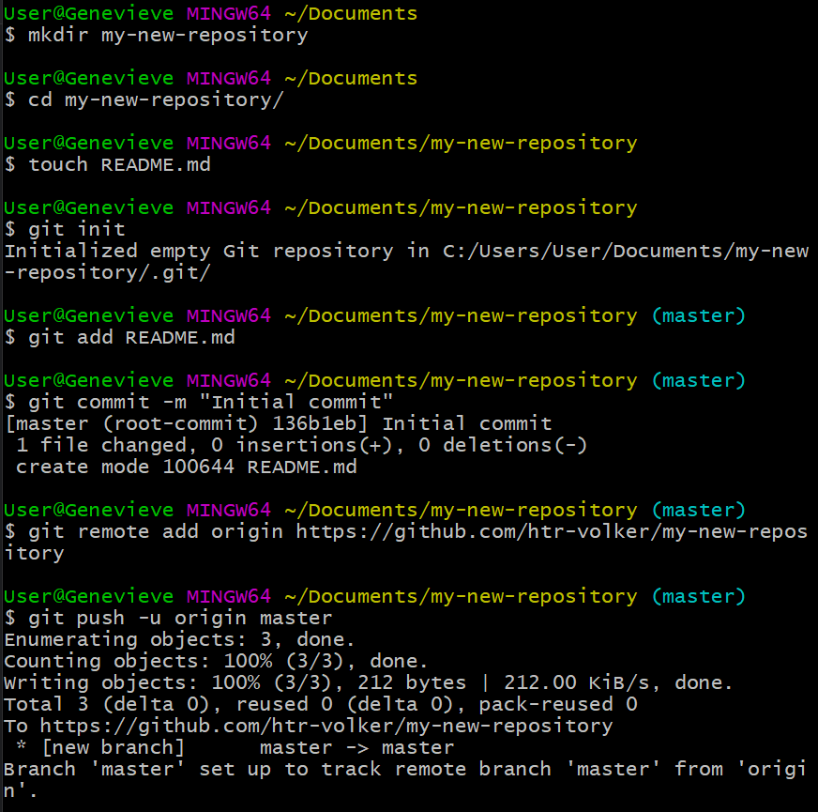

1. Refresh your GitHub repository page on your browser to see your README.md file.

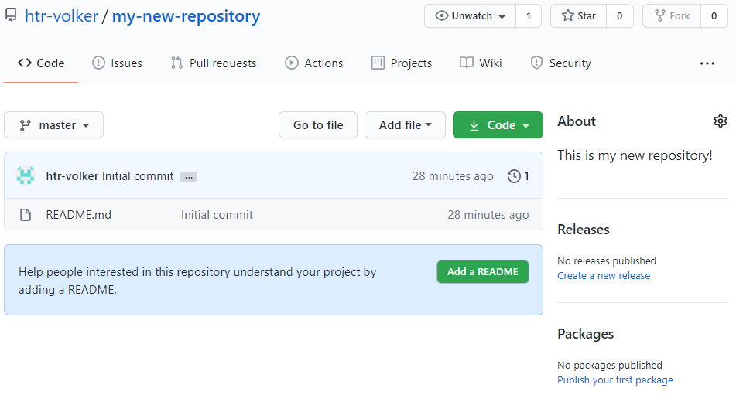

Alternatively, you can create the repository in a remote location, such as on GitHub.

1. Click on the green **New** button to create a new repository.



1. Give your new repo a name, select the tickbox to **Initialize this repository with a README** and click **Create repository**

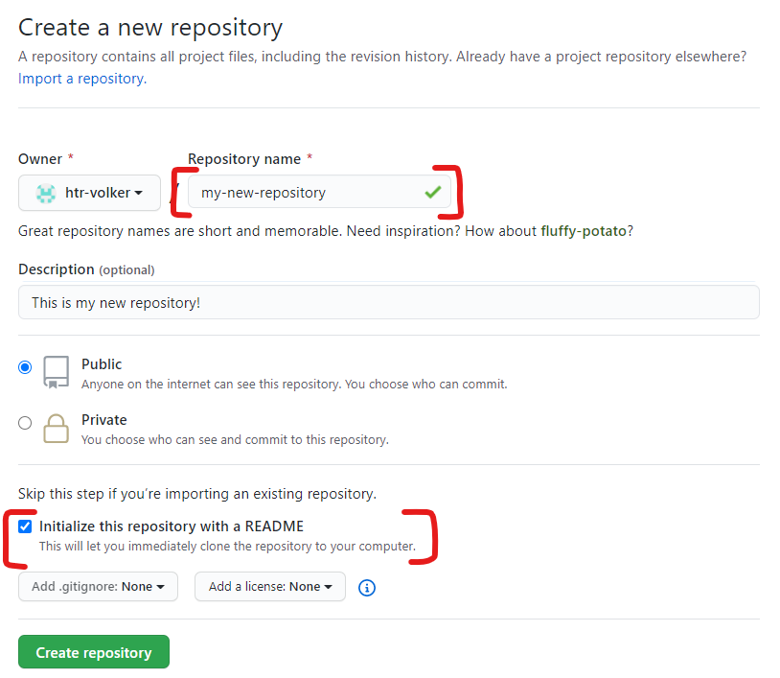

1. Click on the **Code** button and copy the URL provided under the **Clone with HTTPS** section

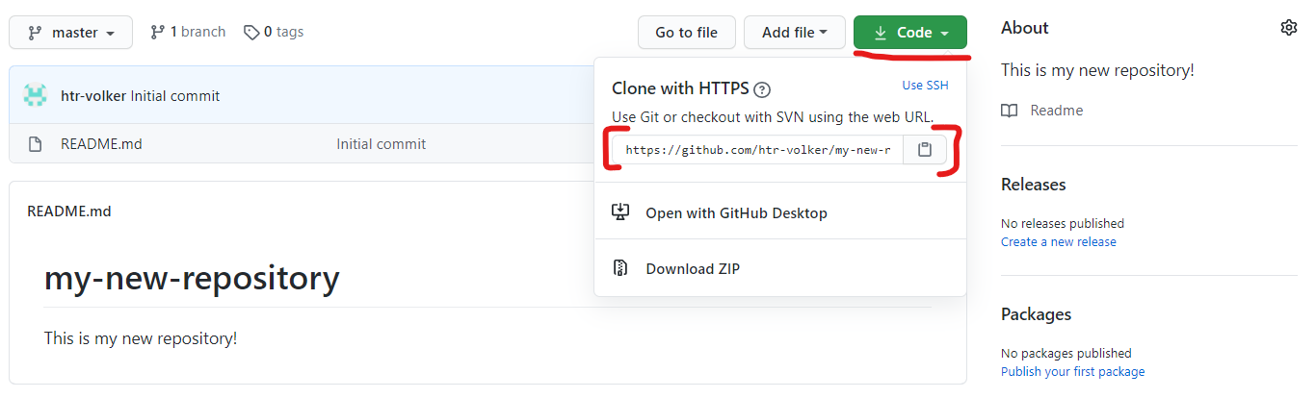

1. Enter the following command in your Bash terminal:

$ cd ..

$ git clone https://github.com/[YOUR_USERNAME]/[YOUR_NEW_REPO]